Nutritional Immunology 營養免疫學

What is Nutritional Immunology?
Nature has blessed us with an incredibly effective fortress against nasty pathogens through the human immune system. With proper nourishment, it is able to build up a strong defense against diseases like cancer, diabetes and influenza. Through the production of “immune soldiers”, such as macrophages, B and T white blood cells, our immune system is well-maintained. The only indication of our immune system being compromised is when we fall sick.
Nutritional immunology is a highly relevant science that revolves around the fundamental desire of human beings to fight diseases and live longer. It studies the link between nutrition and the immune system. It advocates prevention over cure. Like the engine of a car, our immune system requires sufficient fuel for it to always be in peak performance. An appropriate and adequate supply of disease-preventing nutrients like antioxidants, phytochemicals and polysaccharides gives us the nourishment needed to protect our body from daily viral, bacterial and other dangerous threats.
The immune system is the body’s true doctor
Nutritional Immunology highlights that prevention is better than cure
Nutritional Immunology Products are not medications

什麼是營養免疫學？
我們每一个人都擁有上天赐予的一份神奇禮物, 即是人體的免疫系統, 它扮演着一道強大的防线, 能有效抵抗各種疾病。只要給予免疫系統适當的滋養,它就能更好地保護人體免受癌症、糖尿病和流感等疾病侵袭。通過制造巨噬細胞, B細胞 和 T白細胞等”免疫士兵”, 人體的免疫系統能夠有效地识別外來的入侵者並迅速消滅它們。我們周圍的環境中經常存在着各種微生物或細菌, 然而只要免疫系統持續發揮最佳功能, 我們就不會輕易地受到感染。反之, 若免疫系統向病原體妥協, 人體就會患上各種疾病。

营養免疫學是一門独特的科學, 它專門研究有关人體扺抗疾病並活得健康長壽的必要條件。它主要探討营養与免疫系統之間的關聯, 並提倡預防勝於治療。免疫系統就像汽車一樣需要充分的保養才能保持在最佳狀態。因此, 適當地攝取預防疾病的營養, 如抗氧化劑、植物營養素和多醣體能夠滋養人體, 誏免疫系統能夠有效地保護我們不受病毒、細菌和其他危險疾病的威脅。

免疫系統是人體最好的醫生
營養免疫學強調預防勝於治療
營養免疫學產品其實並非藥物
------------------------------------------------------------------------------------------------------------------------------------------------------------------------
3 major nutrients required for a healthy immune system:-
1.) Phytochemicals
2.) Antioxidants
3.) Polysaccharides
Good health = Phyutochemicals, antioxidants and polysaccharides + 3 major criteria
These are not specific components but generic terms. Each of them comes in different types. Each type of phytochemical, antioxidant and polysaccharide
has its own unique health benefit to our body. Plant foods are rich in phytochemicals, antioxidants and polysaccharides which can enhance the human
body's immune system.
Defense ---> Cleanse ---> Repair
Nutrition, immunity, health.
In order to be healthy, one needs to have a healthy immune system; and a healthy immune system needs correct balanced nutrients to defend, cleanse
and repair.
Besides balance nutrients, we must have another three criteria to take note of:
1.) Enough sleep and rest
2.) Appropriate exercise
3.) Stable mood
If we can meet the above three criteria, coupled with the right balance of nutrients, we will certainly get a healthy body.

免疫系統所需要的三大营養
正確的營養是以草本植物,天然而沒有副作用的食物為主。食用的時候要多種類, 並且要吃完整食物而非單一提煉的營養素。富含植物營養素, 抗氧化劑, 多醣体才是真正対人類有用的營養。
1.) 植物營養素
2.) 抗氧化劑
3.) 多醣體
植物營養素、抗氧化劑和多醣體並不是指某一種特定的物质, 這是一種統稱, 它們均含有許多不同的種類。而不同種類的植物的营養素、抗氧化劑和多醣体對人體的健康也具有不同的功能, 正是這些含有豐富的植物營養素、抗氧化劑和多醣體的天然植物、能夠真正促進人體免疫系統的健康。
營養 —> 免疫 —> 健康
一個人如果要獲得健康, 也必須要有健康的免疫系統, 而一個健康的免疫系統必須通過正確均衡的營養才能誏我們的免疫系統達到抵抗、清除與与修
補的功能。當然除了正確均衡的營養以外, 我們還必須具備另三大點。那就是:-
1.) 足夠的睡眠与休息
2.) 適當的運動
3.) 平稳的情緒
如果我們能配合以上三大點, 再配合含正確均衡的營養, 那麼我們肯定會獲得健康的身體。

 Rose玫瑰 Scientific research has verified that the rose provides essential and antioxidants that contribute to beautiful skin.
The rose boosts high concentrations of valuable antioxidants, including ascorbic acids, niacin, flavonoids, and vitamins A, B1, B2, B3, E, and K.
According to experimental reports, the nutrients and antioxidants found in various plant foods, such as rose, may help prevent DNA damage, promote wound healing, and encourage phagocytic activity in addition to improving the skin's texture and appearance.
The high concentration of valuable nutrients in rose makes it fundamental to assisting the proper function and balance of the body's natural systems. Over the centuries, the rose has been used to enhance stomach function, relieve feminine problems, and help increase circulation. Scientists are still trying to determine the specific roles played by rose in disease prevention, but it is clear that rose offers health benefits far beyond traditional skincare.

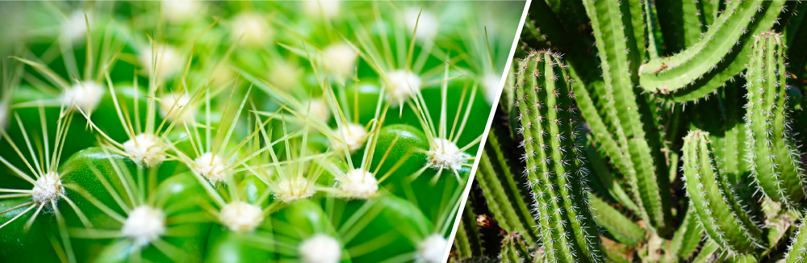 Cactus 仙人掌- The prickly cactus contains more than 10,000 phytochemicals which is the treasure of nutrients.
Boost immunity, reduce the risk of getting diseases:
Research shows that cactus can increase immune efficiency in inhibiting tumor development, fighting the cancer-causing Epstein-Bar Virus (EBV) and immune suppression. This indicates that the cactus has the ability to strengthen the immune system.
Phytochemicals, prevent cancer effectively, it is able to neutralize cancer-causing hormones and inhibit cancer.
Anti-inflammatory, aids in wound healing, speed up wound healing, prevent scars and yet balancing glucose level.
IS CACTUS RELATED TO ALOE VERA?
Aloe vera and cacti may look similar but they belong to entirely different botanical plant families.
Aloe vera can take about 2 years to grow about 60 cm in height.
Some species of cactus, on the other hand, may take 10 years to grow only about 4 cm tall.

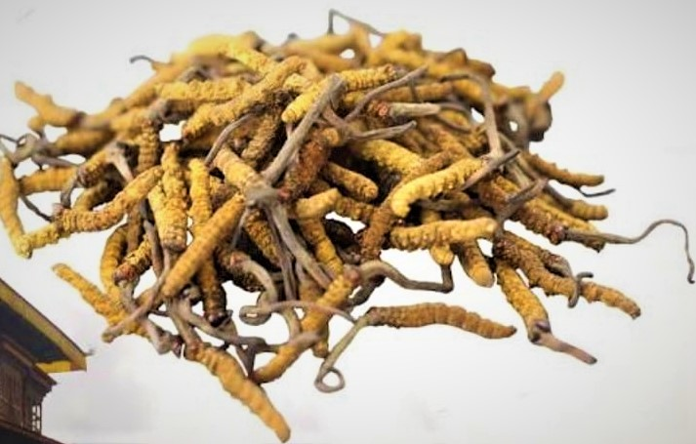 Cordyceps Mycelium 冬蟲夏草菌絲體
High up in the mountains of China grows one of the most valued mushrooms - Cordyceps Sinensis. According to the book Bengcao Congxin (New Compilation of Material Medica) written in the Qing Dynasty, Cordyceps.
Cordyceps mycelium has an astounding array of polysaccharides and many other nutrients that are highly beneficial to health:
*Powerful anti-cancer effect, slows down the spread of cancer cells
*Regulates the immune system
*Protects against free radical damage with excellent antioxidant effects
*Lowers blood lipid levels, strengthens heart, lung, and kidney functions
*Increases energy and vitality, increase resistance to stress.
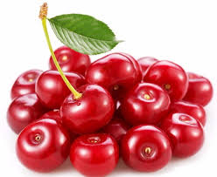 Acerola Cherries 針葉櫻桃

Originating in tropical American, acerola cherries are naturally rich in vitamin C, a powerful antioxidant. High amounts of vitamin C aid Vitamin B12 and iron absorption. Acerola cherries contain 33 times or over 3,000% the amount of vitamin C in orange juice, making them a perfect complement to vitamin B12 and iron.

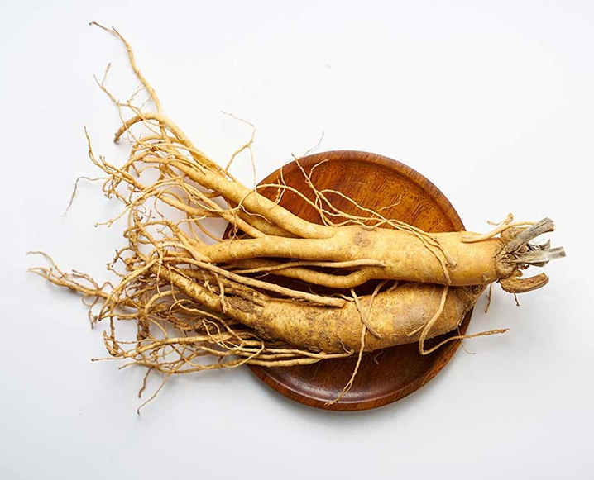 American Ginseng 西洋參
Ginsenosides are a group of phytochemicals that are present only in ginseng. American Ginseng extract contains more than 30 ginsenosides and is highly beneficial to the human body.
Can increase body energy, the blood supply to our brain for better concentration and prevent memory loss. It reduces stress as well as protecting our brains from harmful hormones, reduces fatigue, and boosts energy.

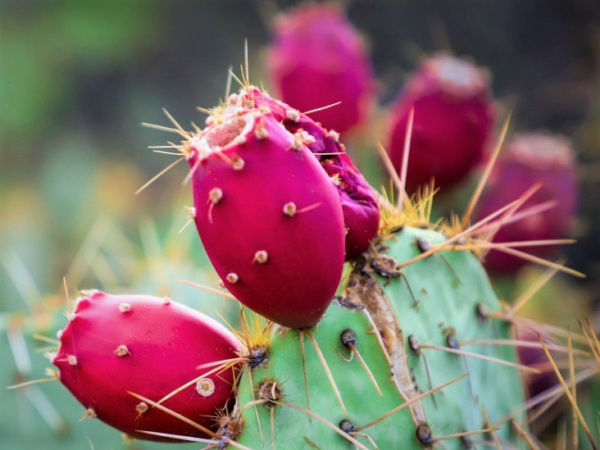 Cactus Fruit 仙人掌果 實
The brightly coloured cactus fruit can take up to four years to develop and ripen. Cactus fruit is rich in antioxidants and phytonutrients that contribute to a healthy body, both externally and internally, which are 7 times higher than Vitamin C.

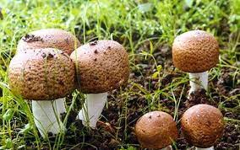 Agaricus Brazil Murill 巴西蘑菇
ABM Mushroom is able to stimulate the production of cancer-fighting lymphocyte T-cells, helper T-cells interferon and interleukin. It increases the activity rate of natural killer cells in our body 38-49 times, enabling our body to destroy cancer cells and viruses in a quick and effective way.

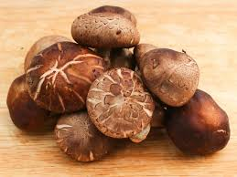 Shiitake Mushroom 椎茸 / 香菇
The Shiitake Mushroom is often called the "nice-smelling mushroom" or "black mushroom". For many centuries, Shiitake Mushroom has been used in Oriental folk medicine to treat colds, flu, poor blood circulation, upset stomach and exhaustion.
It helps in improve chronic problems like long periods of stress and chronic fatigue syndrome.

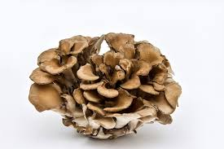 Maitake Mushroom 舞茸
The Maitake Mushroom is high in beneficial polysaccharides, beta-glucan as well as other polysaccharides including phospholipids, nucleotides and unsaturated fatty acids, it can enhance immune function as well as inhibit tumor growth.
It is reported to be helpful in the treatment or prevention of cancer, AIDS, high blood pressure, diabetes, obesity and high cholesterol.

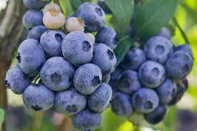 Blueberries 藍莓
Blueberries are tiny, mighty disease-fighting warriors. Brimming with health-promoting compounds, they give a delicious boost to your heart, immune system, brain, eyes and musculoskeletal system.
* Boost the immune system
* Support heart and liver health
* Help prevent cancer
* Protect brain cells
* Improve vision
* Fortify bones and muscles
* Promote urinary tract health

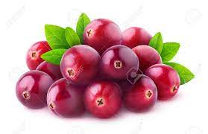 Cranberry 蔓越莓
Cranberry also contains antioxidant super popular "proanthocyanidins" with a special antioxidant capacity and free muscle remove those conditions, to avoid damage cells and maintain the health and viability of the cells.
Combination of high amount of phytochemicals and antioxidants with greatly enhance the body's ability to produce its own amount of collagen needed, generate natural collagen in our body maintaining skin firmness and elasticity it helps to prevent aging of internal organs, remain youthful, protect our eyes and joints, prevents osteoporosis and cancer.

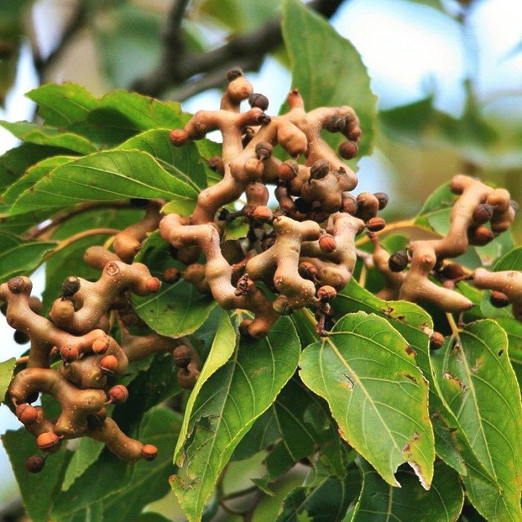 Oriental Raisintree Fruit 枳椇子 (萬壽果)
Raisin Tree fruit can protect liver functions, dispel hangover, activate collaterals to promote blood circulation, increase vitality, maintain a healthy stomach and spleen. It can reduce hypertension, hyperlipidemia, blood viscosity, prevent cancer and so on.

There are more natural plant foods that are good for the human body, and help prevent or improve your health condition.
There is a product that combines all the extract from the various plant foods type ingredients mentioned and listed above for easy consumption.
If you would like to find out more, please write to BePearls at:-
BePearls2021@gmail.com or text message to +65 9632 5883
We are welcome your query and comment, will respond to your email or text message as soon as possible!
還有更多對人體有益的天然植物性食品，有助於預防或改善您的健康狀況。
有一種產品結合了上述和列出的各種植物性食品成分的所有提取物，以方便於食用。
如果您想了解更多信息，請寫信給BePearls：
BePearls2021@gmail.com或發短信至+65 9632 5883
我們歡迎您的查詢和評論，將會盡快回复您的電子郵件或短信！

------------------------------------------------------------------End-----------------------------------------------------------------------------------------

